**Spring Boot Web Project**

**Project Name**: spring-learn  
**Technology Used**: Spring Boot, Maven

**Objective:**

To create a Spring Boot web project using Maven, explore its structure, configure logging, and run the application successfully.

**🔧 Steps Followed:**

**1. Project Initialization**

* Used [https://start.spring.io](https://start.spring.io/) with the following configuration:
  + **Group**: com.cognizant
  + **Artifact**: spring-learn
  + **Dependencies**: Spring Web, Spring Boot DevTools
* Extracted the ZIP to Eclipse workspace.

**2. Importing into Eclipse**

* Followed:
* File > Import > Maven > Existing Maven Projects
* Selected the extracted folder and finished importing.

**3. Building the Project**

* Ran the Maven build command:

PS C:\Users\chait\eclipse-workspace\spring-learn> mvn clean package

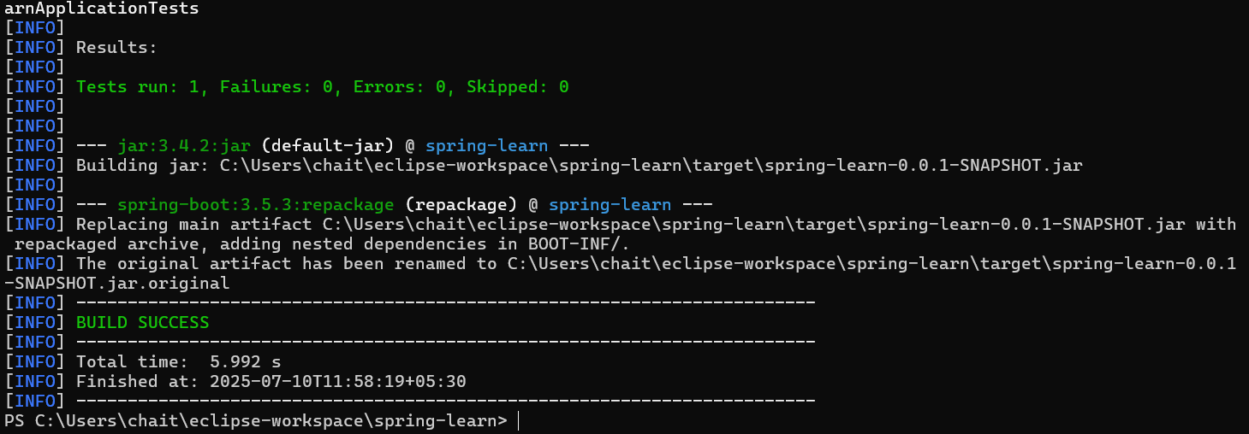

**4. Application Code Setup**

* Located SpringLearnApplication.java inside:
* src/main/java/com/cognizant/spring_learn/

SpringLearningApplication.java:

package com.cognizant.spring_learn;

import org.slf4j.Logger;

import org.slf4j.LoggerFactory;

import org.springframework.boot.SpringApplication;

import org.springframework.boot.autoconfigure.SpringBootApplication;

*@SpringBootApplication*

public class SpringLearnApplication {

public static final Logger *log* = LoggerFactory.*getLogger*(SpringLearnApplication.class);

public static void main(String[] args) {

SpringApplication.*run*(SpringLearnApplication.class, args);

*log*.info("Main Program Executed");

}

}

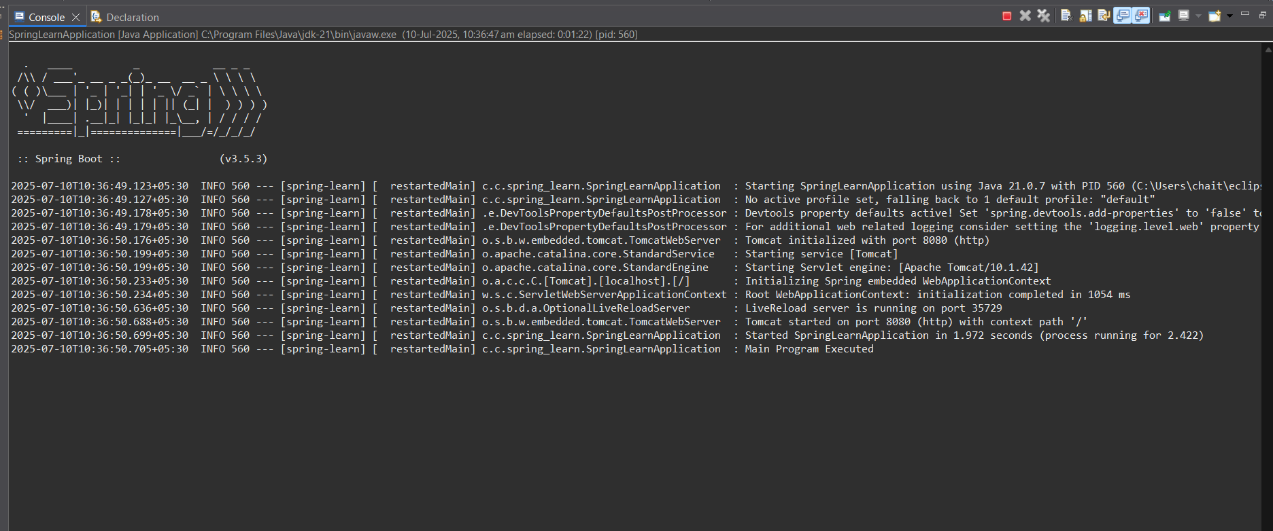**vvhshsjhj 5. CONSOLE :**

**🗂 Project Structure Overview:**

| **Folder / File** | **Purpose** |
| --- | --- |
| src/main/java | Application source code |
| src/main/resources | Configuration files (e.g., application.properties) |
| src/test/java | Placeholder for test classes |
| pom.xml | Maven build configuration |

**🔍 Maven Dependency Hierarchy:**

PS C:\Users\chait\eclipse-workspace\spring-learn> mvn dependency:tree

